**DATA COMMUNICATION AND NETWORKS**

**LAB 5**

|  |  |
| --- | --- |
| NAME | Aaradhya Bhatiya |
| SAP | 500108359 |
| BATCH | B2 |

**SETUP:**

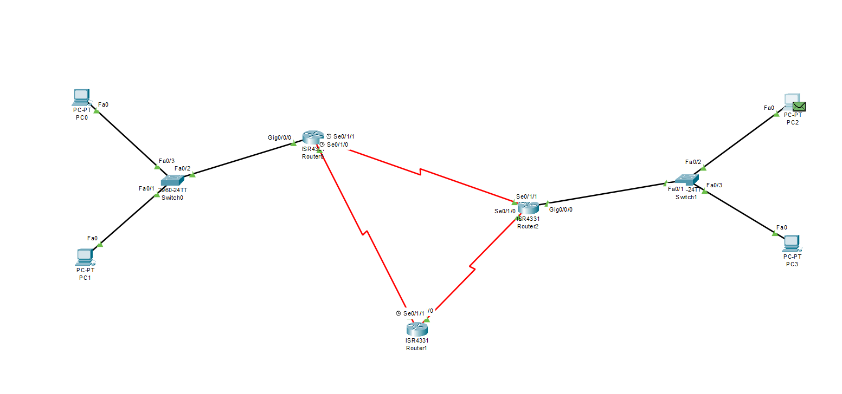

* THIS SETUP HAS
* 3 ROUTERS
* 2 SWITCHES
* 4 DEVICES
* TOTAL NERWORKS: 5

1. **IP OF RESPECTIVE DEVICES**

Of left network

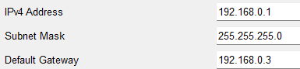 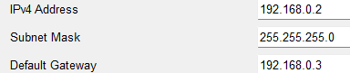

Of right network

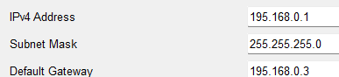 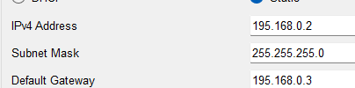

1. **CONFIGURATION COMMANDS OF THE THREE ROUTERS**

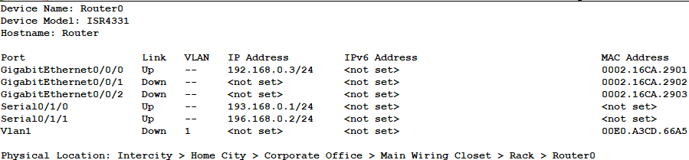R0:

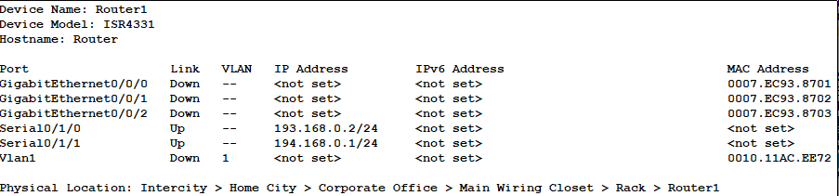R1:

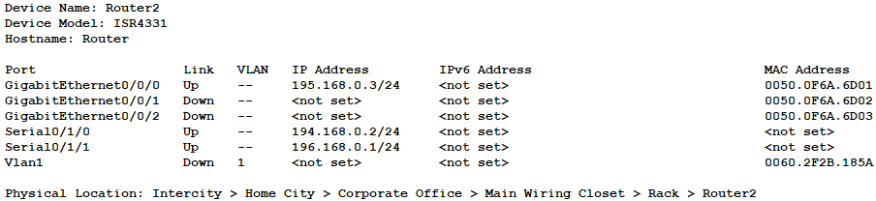R2:

1. **THE REAL TIME MESSAGE SENDING PROCESS**

FROM PC1 TO PC1

STEP1: FROM DEVICE TO SWITCH

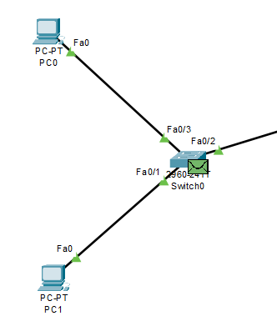

STEP2: FROM SWITCH TO ROUTER-0

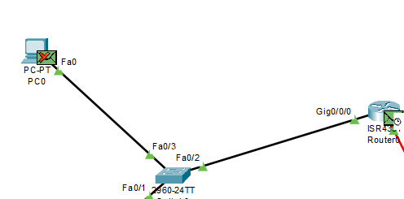

STEP 3: FROM ROUTER-0 TO ROUTER-1 AND ROUTER-1 TO ROUTER-2

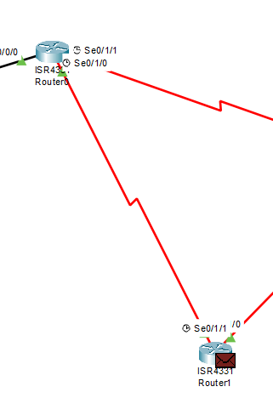 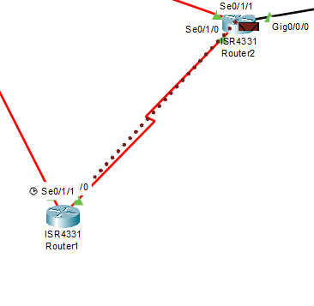

STEP 4: FROM ROUTER-2 TO SWITCH AND THEN SWITCH TO DEVICES

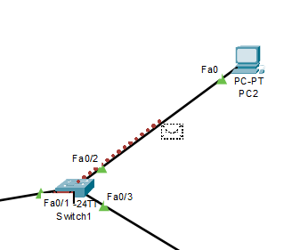

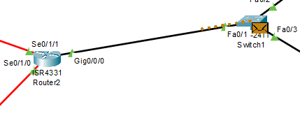

NOW THE MESSAGE WILL TRACE BACK TO THE SWICH AND PASS THROUGH

FROM ROUTER-2 TO DIRECTLY ROUTER-0 INSTEAD OF GOING TO ROUTER-1

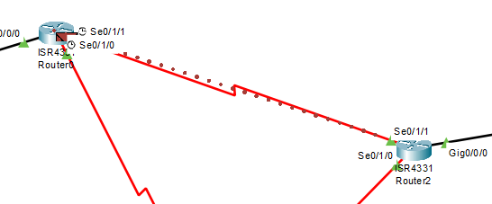

Final status:

